**Challenge 1 - Encapsulation**

Encapsulation Cat



Encapsulation Fish

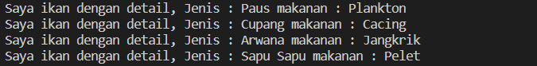

Encapsulation Flower

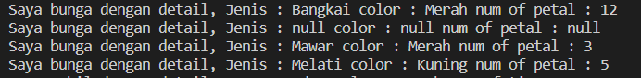

Encapsulation Car

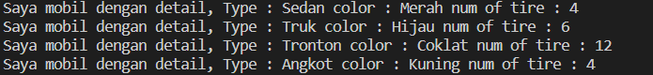

**Challenge 2 - Data Abstraction**

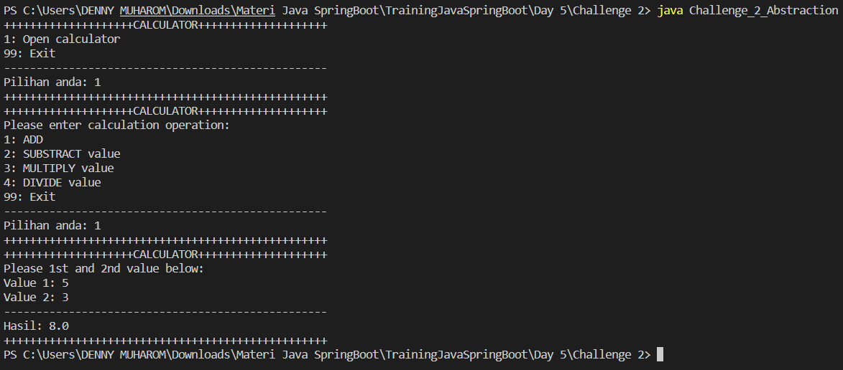

**Challenge 3 - Inheritance & Polymorpishm (Vehicle)**

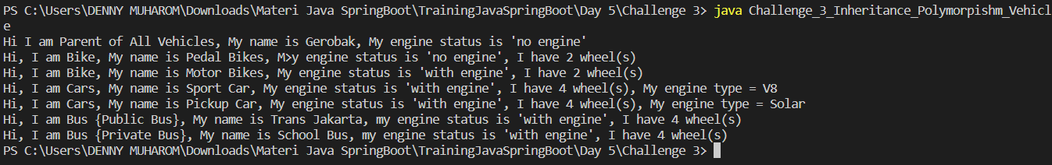

**Challenge 4 - Inheritance & Polymorpishm (Animals)**

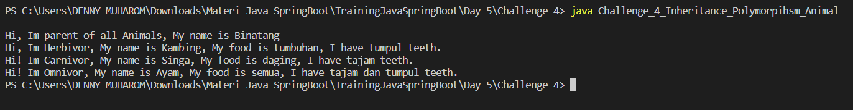

**Challenge 5 - Salah Kandang**